Task 1: Academic Management System.

**1. Database Creation**

create database student_database;

use student_database;

1. create table StudentInfo

(STU_ID int, STU_NAME varchar(100),

DOB DATE, PHONE_NO VARCHAR(10),EMAIL_ID varchar(50),

ADDRESS varchar(250),primary key (STU_ID));

1. create table CourseInfo

(COURSE_ID INT ,COURSE_NAME VARCHAR(100), COURSE_INSTRUCTOR_NAME VARCHAR(100), primary key (COURSE_ID));

1. create table EnrollmentInfo

(ENROLLMENT_ID INT, STU_ID int, COURSE_ID INT, ENROLL_STATUS varchar(20),

primary key (ENROLLMENT_ID),

FOREIGN KEY (STU_ID) REFERENCES StudentInfo(STU_ID),

FOREIGN KEY (COURSE_ID) REFERENCES CourseInfo(COURSE_ID));

**2. Data Creation:**

a) Insert Into StudentInfo

(STU_ID, STU_NAME, DOB, PHONE_NO, EMAIL_ID ,ADDRESS) Values

('1001', 'Tom Hardy', '1993-08-23',9999999991, 'tom101@gamil.com', 'Banglore'),

('1002', 'Sam Joseph', '1994-08-23',9999999992, 'sam102@gamil.com', 'Banglore'),

('1003', 'Ben Issac', '1993-08-25',9999999993, 'ben103@gamil.com', 'Chennai'),

('1004', 'Kane Lewis', '1993-10-23',9999999994, 'kane104@gamil.com', 'Mumbai'),

('1005', 'Ian Robert', '1994-06-14',9999999995, 'ian105@gamil.com', 'Delhi'),

('1006', 'John Austin', '1991-07-17',9999999996, 'john106@gamil.com', 'Kochi');

b) Insert Into CourseInfo(COURSE_ID,COURSE_NAME, COURSE_INSTRUCTOR_NAME) values

(1, 'SQL','David'),

(2, 'Python','Artur'),

(3, 'AWS','Sebastian'),

(4, 'JAVA','Harry'),

(5, 'CSS','Jack');

c) insert into EnrollmentInfo(ENROLLMENT_ID, STU_ID, COURSE_ID, ENROLL_STATUS) values

(10001, 1001, 001,'ENROLLED'),

(10002, 1003, 002,'ENROLLED'),

(10003, 1004, 004,'ENROLLED'),

(10004, 1002, 003,'ENROLLED'),

(10005, 1005, 003,'NOT ENROLLED'),

(10006, 1006, 005,'ENROLLED');

3) **Retrive the Student Information**

a) Write a query to retrieve Student details, Such as Student Name, Contact Informations and Enrollment Status

Select s.STU_NAME, s.PHONE_NO, s.ADDRESS,

e.ENROLL_STATUS

from StudentInfo s join EnrollmentInfo e

on s.STU_ID=e.STU_ID order by e.ENROLL_STATUS ASC;

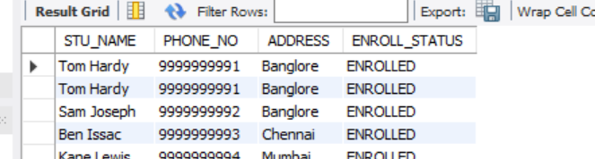

b) Write a query to retrieve a list of courses in which a specific student enrolled.

select c.COURSE_NAME, s.STU_NAME

from EnrollmentInfo e join CourseInfo c on e.course_id = c.course_id

join StudentInfo s on s.STU_ID = e.STU_ID

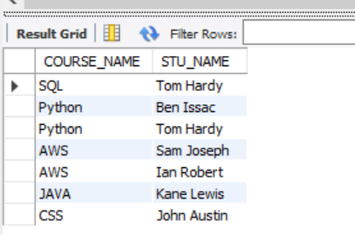

C) Write a query to retrieve course information, including course name, insturctor information.

Select * From CourseInfo;

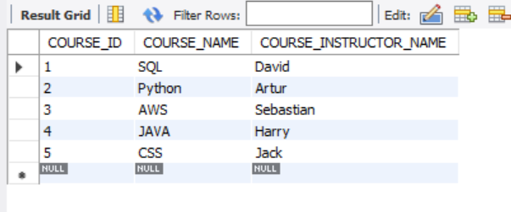

d) Write a query to retrieve course information for a specific course.

Select COURSE_ID,COURSE_NAME, COURSE_INSTRUCTOR_NAME

from CourseInfo

where COURSE_NAME='SQL';

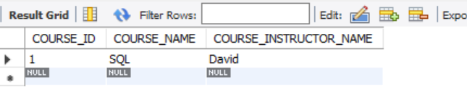

e) Write a query to retrieve course information for multiple courses.

Select COURSE_ID,COURSE_NAME, COURSE_INSTRUCTOR_NAME

from CourseInfo

where COURSE_NAME in ('SQL','Python');

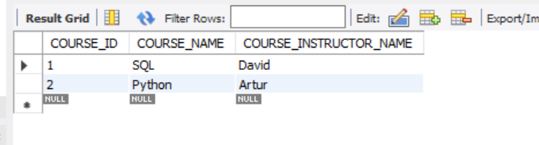

f) Test the queries to ensure accurate retrieval of Student Information.

(Excecute queries and verify the results against the expected output.)

Select * From StudentInfo;

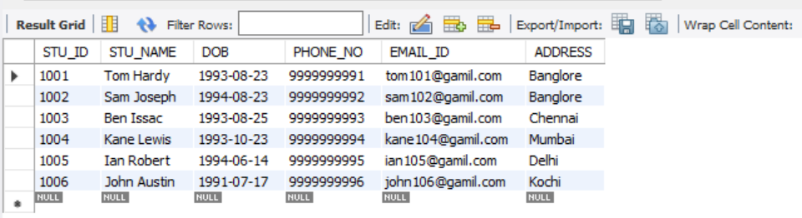

**4. Reporting and Analytics (Using joining queries)**

a) Write a query to retrieve the number of students enrolled in each course

Select c.Course_Name , count(c.course_id) as numberofStud

from CourseInfo c join EnrollmentInfo e

on c.course_id=e.course_ID

where e.enroll_status = 'ENROLLED'

group by 1

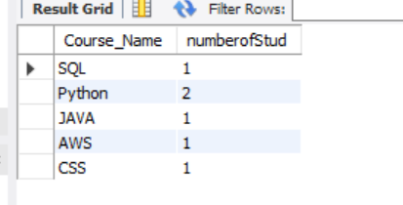

b) Write a query to retrieve the list of students enrolled in a specific course

select e.COURSE_ID, c.COURSE_NAME, s.STU_NAME

from CourseInfo c join EnrollmentInfo e on c.course_id=e.course_ID

join StudentInfo s on s.STU_ID = e.STU_ID where e.enroll_status = 'ENROLLED';

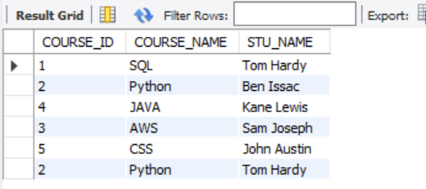

c)Write a query to retrieve the count of enrolled students for each instructor.

Select c.COURSE_INSTRUCTOR_NAME , count(e.Stu_id) as numberofStud

from CourseInfo c join EnrollmentInfo e

on c.course_id=e.course_ID

where e.enroll_status = 'ENROLLED'

group by 1;

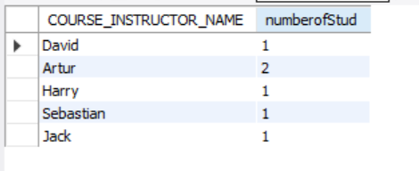

d) Write a query to retrieve the list of students who are enrolled in a multiple course

Select e.stu_id , count(c.course_id) as numberofStud

from CourseInfo c join EnrollmentInfo e

on c.course_id=e.course_ID

where e.enroll_status = 'ENROLLED'

group by 1

having count(c.course_id) >1

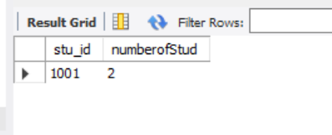

e) Write a query to retrieve the courses that have the highest number of enrolled students(arranging from highest to lowest)

Select e.stu_id , count(c.course_id) as numberofStud

from CourseInfo c join EnrollmentInfo e

on c.course_id=e.course_ID

where e.enroll_status = 'ENROLLED'

group by 1

having count(c.course_id) >1

order by count(c.course_id) desc



**Task2: Student Database Management System:**

**1) Database setup**

a) Create student database:

CREATE DATABASE "Student_Database"

WITH

OWNER = postgres

ENCODING = 'UTF8'

LC_COLLATE = 'English_United States.1252'

LC_CTYPE = 'English_United States.1252'

TABLESPACE = pg_default

CONNECTION LIMIT = -1

IS_TEMPLATE = False;

b) Student table creation:

create table Student_table

(Student_id int, Stu_name varchar(100),

Department varchar(50), email_id varchar(50),

Phone_no numeric, Address varchar(250),

Date_Of_Birth DATE, Gender Varchar(30),

Major Varchar(50), GPA numeric, Grade varchar(10));

**2) Data entry**

10 sample records inserted:

Insert Into Student_table

(Student_id, Stu_name, Department, email_id, Phone_no, Address

,Date_Of_Birth, Gender, Major, GPA, Grade) Values

('1', 'Muskaan Arya', 'Business', 'muskaan@gmail.com', '9999999991',

'Delhi', '1999-04-26', 'Female', 'MBA', '8.8', 'A'),

('2', 'Kundan Kumar', 'Arts and Sciences', 'kundan@gmail.com',

'9999999992', 'Bangalore', '1992-07-15', 'Male', 'Mathematics', '8.6', 'A'),

('3', 'Rajat Nema', 'Business', 'Rajat@gmail.com', '9999999993',

'Delhi', '1995-06-28', 'Male', 'MBA', '8.5', 'A'),

('4', 'Devashish Negi', 'Arts and Sciences', 'Devashish@gmail.com',

'9999999994', 'Dehradhun', '1997-01-12', 'Male', 'Physics', '7.6', 'B'),

('5', 'Karishma Roy', 'Arts and communication', 'Karishma@gmail.com',

'9999999995', 'Mumbai', '1995-10-26', 'Female', 'Communication', '6.9', 'B'),

('6', 'Shivani Saini', 'Arts and Sciences', 'Shivani@gmail.com',

'9999999996', 'Goa', '2000-01-03', 'Female', 'Computer Science', '5.5', 'C'),

('7', 'Himanshu Chawla', 'Human Development', 'Himanshu@gmail.com',

'9999999997', 'Uttar Pradesh', '2000-10-05', 'Male', 'Counseling', '7.0', 'B'),

('8', 'Pranshu Yadav', 'Arts and communication', 'Pranshu@gmail.com',

'9999999998', 'Gujarat', '1999-11-16', 'Male', 'Theatre', '9.2', 'A'),

('9', 'Sarthak Arya', 'Business', 'Sarthak@gmail.com', '9999999999',

'Rajasthan', '2003-08-14', 'Male', 'Accounting', '7.9', 'B'),

('10', 'Sanya Gambhir', 'Arts and Sciences', 'Sanya@gmail.com',

'9999999911', 'Mumbai', '1997-03-12', 'Female', 'Physics', '4.9', 'C');

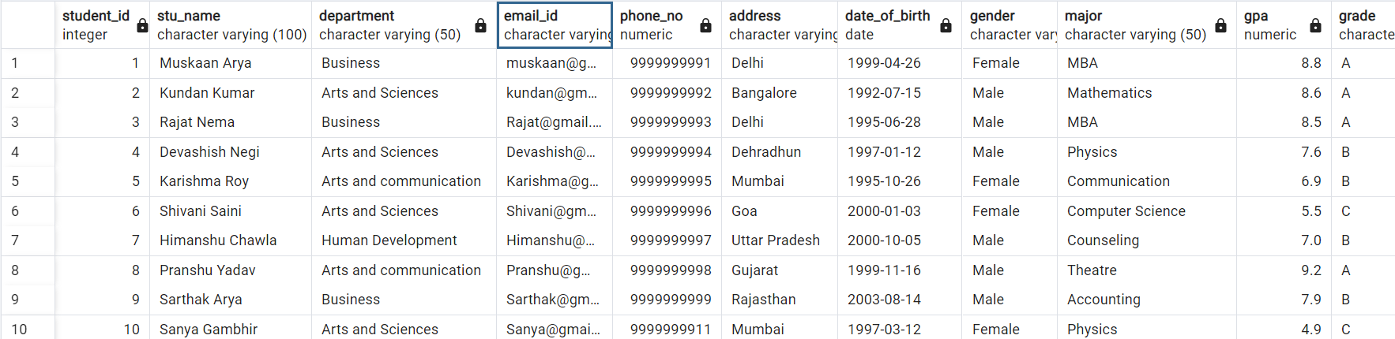

**3) Student information retrieval**

Select * from Student_table

Order By GPA desc, Grade;

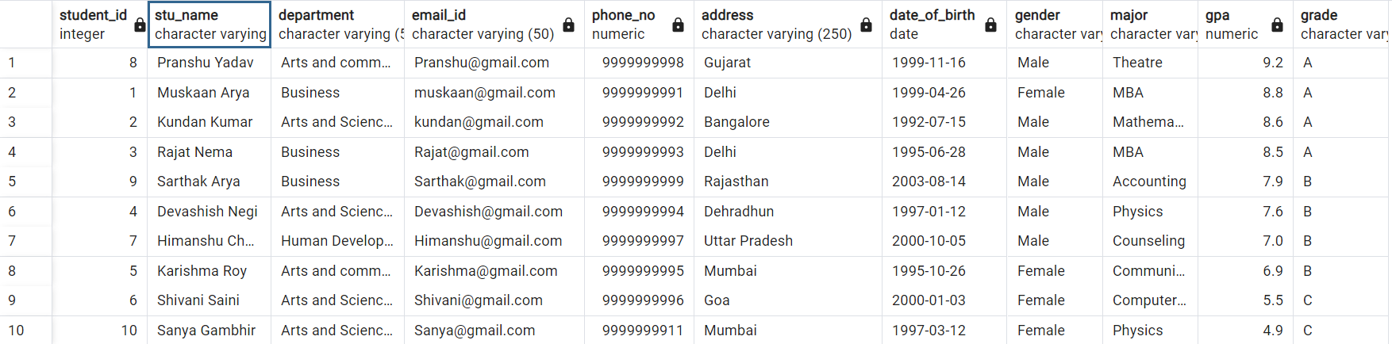

**4) Query for Male students**

Select * from Student_table

where Gender = 'Male'

;

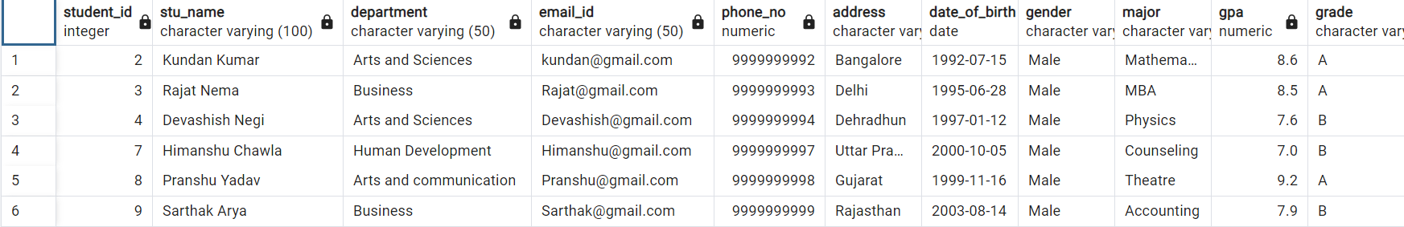

**5)GPA less than 5**

Select * from Student_table

where GPA <5.0

;



**6)Update email_id and Grade**

UPDATE Student_table

SET email_id = 'Sanyaa@gmail.com', Grade = 'D'

Where Student_id = '10';

**7)Query Grade B**

SELECT Stu_name, date_part('year',age(Date_Of_Birth)) as Age

FROM Student_table

Where Grade = 'B'

;

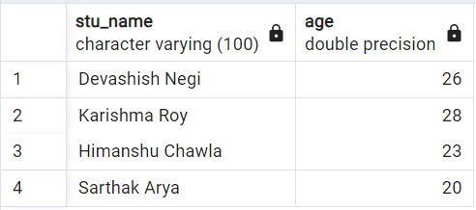

**8) Grouping and calculation**

Select Department, Gender, Avg(GPA)

From Student_table

Group By 1,2

;

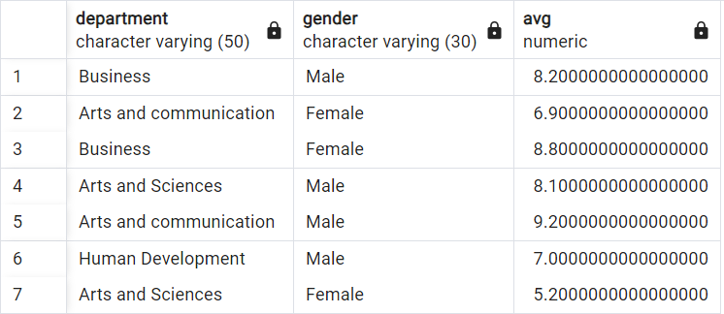

**9)Table Renaming**

Alter table Student_table

Rename to Student_info;

Select * from Student_info

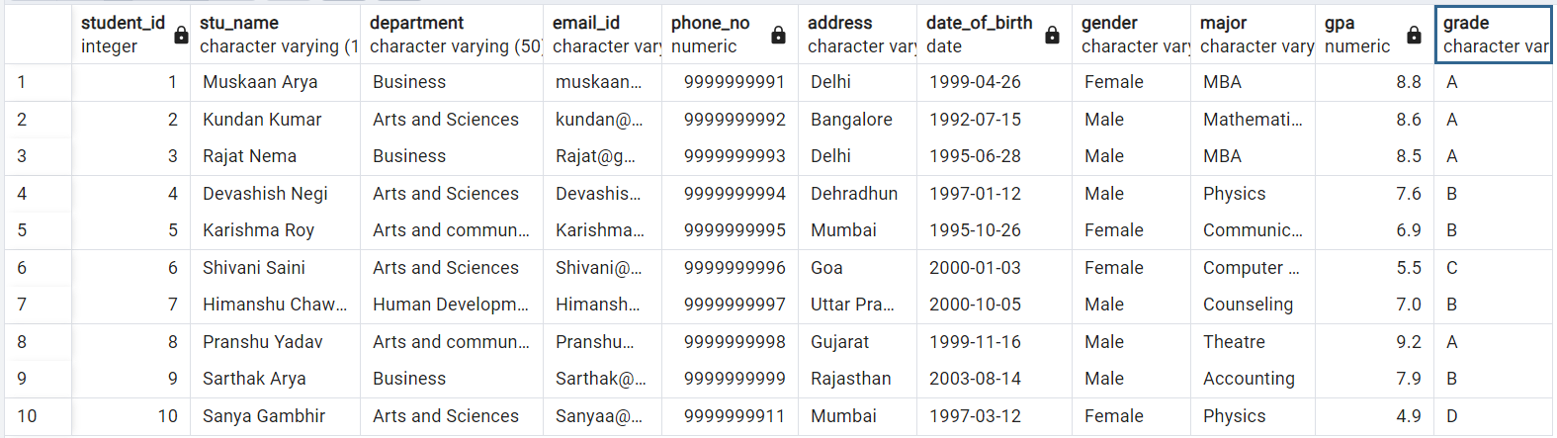

**10)Students with highest GPA**

Select Stu_name, GPA

From Student_info where GPA = (Select Max(GPA) From Student_info)

;

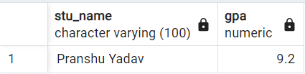

**Task 3 : EventsManagement System**

1. **Database creation**

CREATE DATABASE "EventsManagement"

WITH

OWNER = postgres

ENCODING = 'UTF8'

LC_COLLATE = 'English_United States.1252'

LC_CTYPE = 'English_United States.1252'

TABLESPACE = pg_default

CONNECTION LIMIT = -1

IS_TEMPLATE = False;

a. Table Creation

Create table Events (Event_Id Int, Event_Name Varchar(30), Event_Date Date,

Event_Location Varchar(100), Event_Description Varchar(200), primary key (Event_Id));

Create table Attendees (Attendee_Id Int, Attendee_Name Varchar(30),

Attendee_Phone numeric, Attendee_Email Varchar(30), Attendee_City Varchar(20),

primary key (Attendee_Id));

Create table Registrations (Registration_Id Int, Event_Id Int, Attendee_Id Int,

Registration_Date Date, Registration_Amount numeric, primary key (Registration_Id),

FOREIGN KEY (Event_Id) REFERENCES Events(Event_Id),

FOREIGN KEY (Attendee_Id) REFERENCES Attendees(Attendee_Id));

**2. Data Creation**

Insert into Events

(Event_Id, Event_Name, Event_Date, Event_Location, Event_Description) values

('101', 'Ed Sheeran', '2024-03-03', 'Mumbai', 'Music Show'),

('102', 'Comicon 2023', '2023-11-19', 'Bangalore', 'Exhibition'),

('103', 'IIMF', '2023-11-12', 'Kerala', 'Music Show'),

('104', 'Who are You', '2024-01-06', 'Delhi', 'Comedy'),

('105', 'Champak chacha', '2024-02-13', 'Kolkata', 'Comedy')

;

Select * from Events;

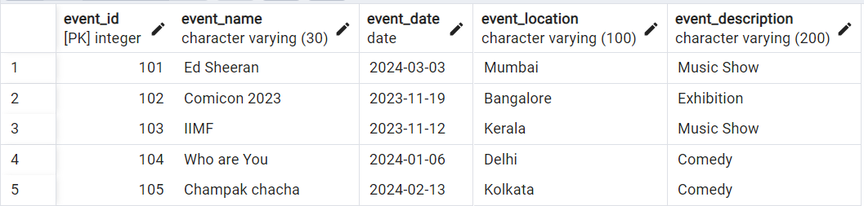

Insert into Attendees (Attendee_Id, Attendee_Name, Attendee_Phone, Attendee_Email, Attendee_City) values

('1001', 'Muskaan', '9999999991', 'Muskaan@gmail.com', 'Delhi'),

('1002', 'Rajat', '9999999992', 'Rajat@gmail.com', 'Delhi'),

('1003', 'Abhinav', '9999999993', 'Abhinav@gmail.com', 'Mumbai'),

('1004', 'Kundan', '9999999994', 'Kundan@gmail.com', 'Uttar Pradesh'),

('1005', 'Karishma', '9999999995', 'Karishma@gmail.com', 'Mumbai'),

('1006', 'Shivani', '9999999996', 'Shivani@gmail.com', 'Goa'),

('1007', 'Devashish', '9999999997', 'Devashish@gmail.com', 'Uttrakhand'),

('1008', 'Sarthak', '9999999998', 'Sarthak@gmail.com', 'Delhi')

;

Select * from Attendees;

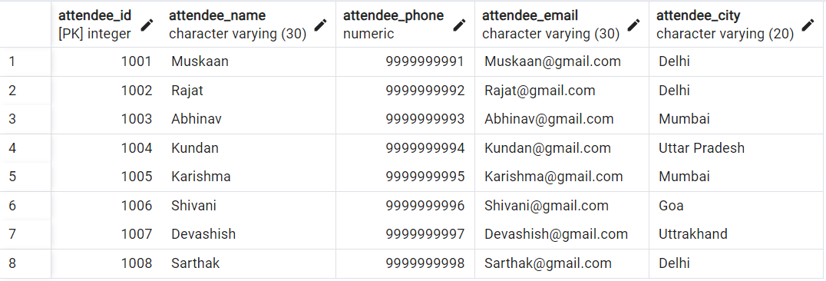

Insert into Registrations

(Registration_Id, Event_Id, Attendee_Id, Registration_Date, Registration_Amount) values

('10001', '101', '1001', '2023-10-12', '7500'),

('10002', '102', '1003', '2023-09-25', '1000'),

('10003', '103', '1002', '2023-10-29', '2000'),

('10004', '104', '1004', '2023-10-20', '500'),

('10005', '101', '1005', '2023-09-10', '7500'),

('10006', '103', '1008', '2023-09-15', '2000'),

('10007', '101', '1007', '2023-11-01', '7500'),

('10008', '102', '1006', '2023-11-05', '1000')

;

Select *from Registrations;

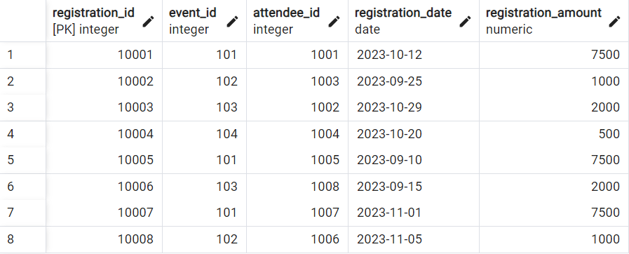

**3) Manage Event Details**

a) Insert New event

Insert INTO Events (Event_Id, Event_Name, Event_Date, Event_Location, Event_Description) VALUES

('106', 'Unheard Diaries', '2023-10-29', 'Delhi', 'Storytelling');

b) Update event's information

UPDATE Events

SET Event_Location = 'Bangalore' Where Event_Id = '104'

;

c) Deleting an event

Delete from Events where Event_Id = '105'

;

**4) Manage Track attendees and handle events**

a) Insert new attendee

Insert into Attendees (Attendee_Id, Attendee_Name, Attendee_Phone, Attendee_Email, Attendee_City)

values ('1009', 'Krishna', '9999999999', 'Krishna@gmail.com', 'Tamil Nadu');

b) Register attendee

Insert into Registrations (Registration_Id, Event_Id, Attendee_Id, Registration_Date, Registration_Amount)

values ('10009', '101', '1009', '2023-11-11', '7500');

**5) Retrieve event information, generate attendee list, Calculate event attendee statistics**

with Event1 as(

select E.Event_id, E.event_name, E.event_date, E.event_location,

sum(R.registration_amount) over(partition by E.event_id) as Amountgenperevent

from Events E join Registrations R on E.event_id = R.event_id

join Attendees A on A.attendee_id = R.attendee_id)

select Event_id, event_name, event_location, Amountgenperevent

from Event1

group by 1,2,3,4

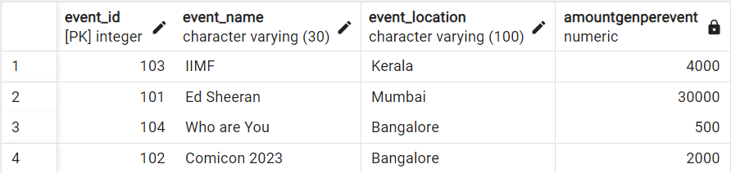

**Task 4: OLAP Operations**

CREATE DATABASE "Sales Data "

WITH

OWNER = postgres

ENCODING = 'UTF8'

LC_COLLATE = 'English_United States.1252'

LC_CTYPE = 'English_United States.1252'

TABLESPACE = pg_default

CONNECTION LIMIT = -1

IS_TEMPLATE = False;

**1) Database creation**

Create table Sales_sample (Product_Id Int, Region Varchar(50), On_date Date,

Sales_Amount Numeric);

**2) Data Creation**

Insert into Sales_sample (Product_Id, Region, On_date, Sales_Amount) values

('1', 'East', '2023-10-10', '20000'),

('2', 'West', '2023-09-19', '50000'),

('2', 'East', '2023-10-21', '40000'),

('3', 'North', '2023-09-20', '15000'),

('4', 'North', '2023-08-06', '45000'),

('2', 'South', '2023-08-25', '45000'),

('5', 'North', '2023-11-23', '20000'),

('5', 'West', '2023-11-11', '60000'),

('3', 'East', '2023-09-19', '50000'),

('1', 'West', '2023-09-29', '70000')

;

Select * from Sales_Sample;

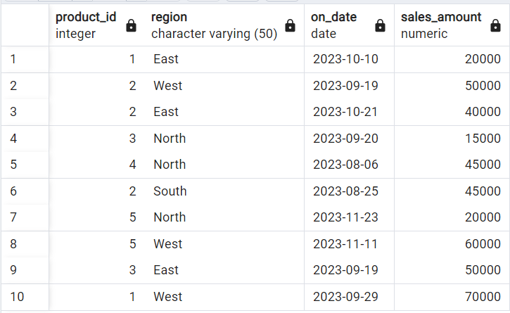

**3) OLAP operations**

a) Drill down

Select Region, Product_Id, Sum(Sales_Amount) as Sales_Amount

From Sales_Sample

Group By 1,2

Order By Region, Product_Id, Sales_Amount

;

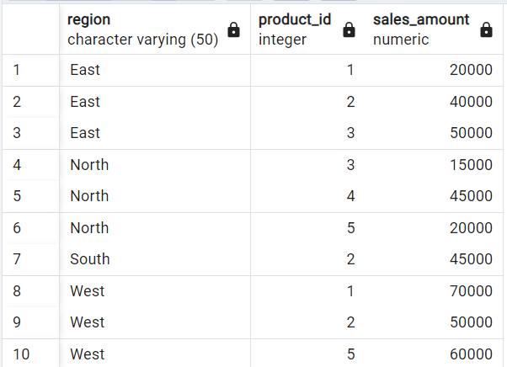

b) Roll Up

Select Region, Product_Id, Sum(Sales_Amount) as Sales_Amount

From Sales_Sample

Group By Rollup (1,2)

Order By Region

;

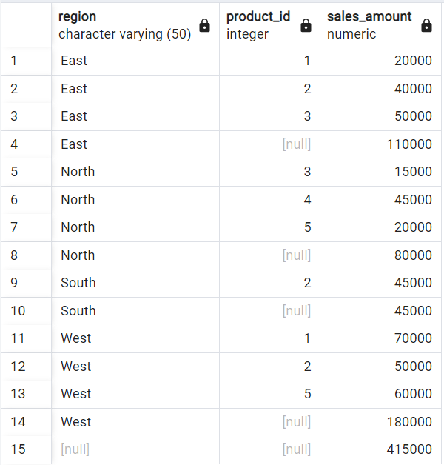

c) Cube

Select Region, Product_Id, On_Date, Sum(Sales_Amount) as Sales_Amount

From Sales_Sample

Group By Cube (1,2,3)

Order By Region, Product_Id, On_Date, Sales_Amount

;

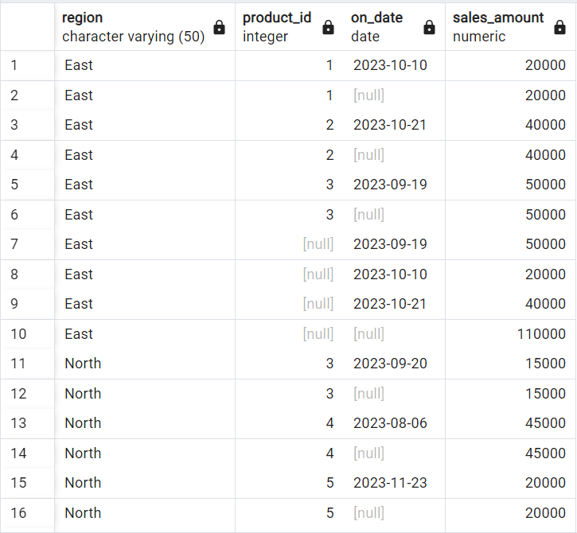

d) Slice

Select Region, Product_Id, On_Date, Sum(Sales_Amount) as Sales_Amount

From Sales_Sample

Where Region in('North', 'South') OR On_Date between To_date('2023-08-20','YYYY-MM-DD') And To_Date('2023-10-20','YYYY-MM-DD')

Group By 1,2,3

Order By Region, Product_Id, On_Date, Sales_Amount

;

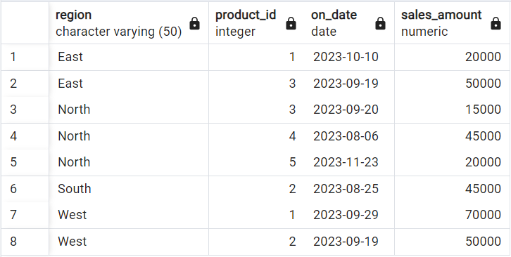

e) Dice

Select Region, Product_Id, On_Date, Sum(Sales_Amount) as Sales_Amount

From Sales_Sample

Where Region in('North', 'South') AND Product_Id IN (1,2) AND On_Date between To_date('2023-08-20','YYYY-MM-DD') And To_Date('2023-10-20','YYYY-MM-DD')

Group By 1,2,3

Order By Region, Product_Id, On_Date, Sales_Amount

;

